**KWAME NKRUMAH UNIVERSITY OF SCIENCE AND TECHNOLOGY**

**CHEMICAL ENGINEERING DEPARTMENT**

**CHE 158: INTRODUCTION TO INFORMATION TECHNOLOGY**

**INSTRUCTOR:** Dr. (Mrs.) Mizpah A. D. Rockson

LECTURE 7: **INPUT AND OUTPUT**

**Learning Objectives**

At the end of the lecture the student is expected to be able to do the following:

1. Define input.
2. Describe keyboard entry including types and features of keyboards.
3. Identify different pointing devices including game controllers and styluses.
4. Describe scanning devices including optical scanners, RFID readers, and recognition devices.
5. Recognize image capturing and audio-input devices.
6. Define output.
7. Identify different monitor features and types including flat panels and e-books.
8. Define printing features and types including inkjet and cloud printers.
9. Recognize different audio and video devices including portable media devices.
10. Define combination input and output devices including multifunctional devices, Internet telephones, and robots.

**7.0 Introduction**

How do you send instructions and information to the CPU? How do you get information out? We input text, music, and even speech, but we probably never think about the relationship between what we enter and what the computer processes. People understand language, which is constructed of letters, numbers, and punctuation marks. However, at a basic level, computers can understand only the binary machine language of 0s and 1s. Input devices are essentially translators. Input devices translate numbers, letters, and actions that people understand into a form that computers can process. Output devices do the reverse.

**7.1 Input**

**Input** is any data or instructions that are used by a computer. They can come directly from you or from other sources (scanned or photographed image). You provide input whenever you use system or application programs. For, example, when using a word processing program, you enter data in the form of numbers and letters and issue commands such as to save and to print documents. You also can enter data and issue commands by pointing to the items or using your voice.

**Input devices** are hardware used to translate words, sounds, images, and actions that people understand into a form that the system unit can process. For example, when using a word processor, you typically use a keyboard to enter text and a mouse to issue commands. In addition to keyboards and mice, there are a wide variety of other input devices. These include pointing, scanning, image capturing and audio-input devices.

Input devices are of 2 kinds:

(1) **Keyboard entry**

(2) **Direct entry:** Direct entry devices create machine-readable data that can go directly to the CPU. This reduces the possibility of human error being introduced (as often humans when data is being entered through a keyboard). There is a variety of direct entry devices. They include pointing, scanning, digitizing, and voice input devices.

**7.2 Keyboard Entry**

One of the most common ways to input data is by **keyboard.** Keyboards convert numbers, letters, and special characters that people understand into electrical signals. These signals are sent to, and processed by, the system unit. Most keyboards use an arrangement of keys given the name **QWERTY**. This name reflects the keyboard layout by taking the letters of the first six characters found on top rows of keys displaying letters.

**7.2.1 Keyboards**

There are a wide variety of different keyboard designs. They range from the full-sized to miniature and from rigid to flexible. There are even virtual keyboards that project an interactive key layout onto a flat surface. There are four basic categories of keyboards: traditional, notebook, virtual and thumb.

* **Traditional keyboards** —full-sized, rigid, rectangular keyboards that include function, navigational, and numeric keys. Some keys, such as Caps Lock key, are toggle keys. These keys turn a feature on or off. Others, such as Ctrl key, are combination keys, which perform an action when held down in combination with another key.
* **Notebook keyboards** —these keyboards are widely used on notebook computers including netbooks. While the precise location and number of keys may differ among manufacturers, notebook keyboards typically have fewer keys, do not include numeric keypad and do not have a standard location for function and navigation keys.
* **Virtual keyboards** —these keyboards are widely used on tablets and on some smartphones. Unlike other keyboards, virtual keyboards do not have a physical keyboard. Rather, the keys are typically displayed on a screen and selected by touching their image on the screen.
* **Thumb keyboards** —these keyboards are widely used smartphones and other small portable devices. Designed primarily for communicating via texting and connecting to the web, these keyboards are very small.

**7.2.2 Features**

A computer keyboard combines a typewriter keyboard with a **numeric keypad,** used to enter numbers and arithmetic symbols. It also has many special-purpose keys. Some keys, such as the CAPS LOCK key, are **toggle keys.** Figure 7.1 explains the keyboard features and their functions.

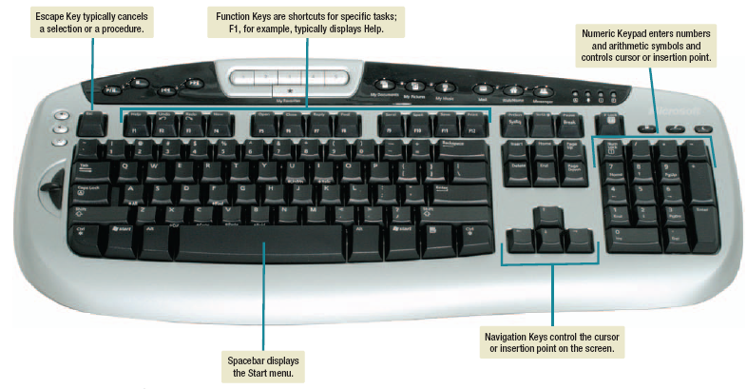

**Figure 7.1: Keyboard features**

These keys turn a feature on or off. Others, such as the CTRL key, are **combination keys,** which perform an action when held down in combination withanother key.

**7.3 Pointing devices**

Pointing is one of the most natural of all human gestures. Pointing devices provide an intuitive interface with the system unit by accepting pointing gestures and converting them into machine-readable input. There are a wide variety of different pointing devices, including the mouse, joystick, touch screen, and stylus.

**7.3.1 Mouse**

A **mouse** controls a pointer that is displayed on the monitor. The **mouse pointer** usually appears in the shape of an arrow. It frequently changesshape, however, depending on the application. A mouse can have one, two,or more buttons, which are used to select command options and to controlthe mouse pointer on the monitor. Some mice have a **wheel button** that canbe rotated to scroll through information that is displayed on the monitor.

Although there are several different mouse types, there are three basic designs:

* **Optical mouse** has no moving parts and is currently the most widely used. It emits and senses light to detect mouse movement. An optical mouse can be used on almost any surface with high precision.

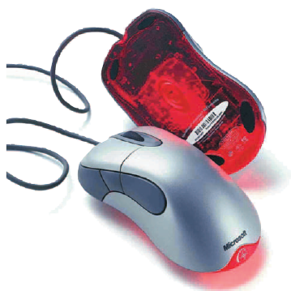

**Figure 7.2: Optical mouse**

* **Mechanical mouse** has a ball on the bottom and is attached with a cord to the system unit. As you move the mouse across a smooth surface, the roller rotates and controls the pointer on the screen.
* **Cordless** or **wireless mouse** is a battery-powered device that typically uses radio waves or infrared light waves to communicate with the system unit. These devices eliminate the mouse cord and free up desk space.

Three devices similar to a mouse are trackballs, touch pads, and pointing sticks. You can use the **trackball,** also known as the **roller ball,** to control the pointer by rotating a ball with your thumb.

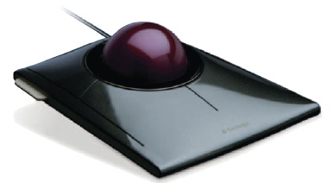

You can use **touch pads** to control the pointer by moving and tapping your finger on the surface of a pad. You can use a **pointing** **stick,** located in the middle of the keyboard, to control the pointer by directing the stick with one finger.

 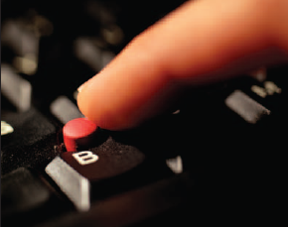

**Figure 7.4: Touch pad Figure 7.5: Pointing stick**

**7.3.2 Touch screen**

A **touch screen** allows users to select actions or commands by touching the screen with a finger or penlike device. Touch screens are easy to use, especially when people need information quickly. They are widely used with tablet PCs, netbooks, and smartphones. Touch screens are also commonly used at restaurants, automated teller machines (ATMs), and information centers. **Multitouch screens** can be touched with more than one finger, which allows for interactions such as rotating graphical objects on the screen with your hand or zooming in and out by pinching and stretching your fingers. Multitouch screens are commonly used on mobile devices such as the Apple iPhone, as well as some notebook computers and desktop monitors.

**7.3.3 Game Controllers**

Game controllers are devices that provide input to computer games. While keyboards and mice can be used as game controllers, the four most popular and specialized game controllers are joysticks, dance pads, gamepads and motion-sensing devices.

The **joystick** is a popular input device for computer games. You control game actions by varying the pressure, speed, and direction of the joystick. Additional controls, such as buttons and triggers, are used to specify commands or initiate specific actions.

**Dance pads** provide input for dance games. Users move (dance) on a pressure sensitive mat that provides input to the game.

**Gamepads** are designed to be held by two hands and provide a wide array of inputs including motion, turning, stopping and firing.

**Motion-sensing devices** control games by user movements. For example, Microsoft’s Kinect motion-sensing device accepts user movements and spoken commands to control games on the Xbox 360.



**7.3.4 Stylus**

A **stylus** is a penlike device commonly used with tablet PCs and PDAs. A stylus uses pressure to draw images on a screen. Often, a stylus interacts with the computer through handwriting recognition software. **Handwriting recognition software** translates handwritten notes into a form that the system unit can process.

**7.4 Scanning devices**

Scanners move across text and images. Scanning devices convert scanned text and images into a form that the system unit can process. There are five types of scanning devices: optical scanners, card readers, RFID readers, bar code readers, and character and mark recognition devices.

**7.4.1 Optical scanners**

An **optical scanner,** also known simply as a scanner, accepts documents consisting of text and/or images and converts them to machine-readable form. These devices do not recognize individual letters or images. Rather, they recognize light, dark, and colored areas that make up individual letters or images. Typically, scanned documents are saved in files that can be further processed, displayed, printed, or stored for later use. There are three basic types of optical scanners: flatbed, document, and portable.

* **Flatbed scanner** is much like a copy machine. The image to be scanned is placed on a glass surface and the scanner records the image from below.
* **Document scanner** is similar to a flatbed scanner except that it can quickly scan multipage documents. It automatically feeds one page of a document at a time through a scanning surface.
* **Portable scanner** is typically a handheld device that slides across the image, making direct contact.

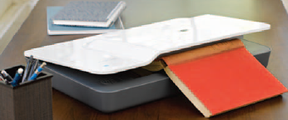 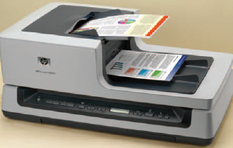

**Figure 7.6: Flatbed scanner Figure 7.7: Document scanner**

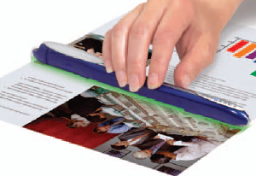

**Figure 7.8: Portable scanner**

**7.4.2 Card readers**

Nearly everyone uses a credit card, debit card, access (parking or building) card, and/or some type of identification card. These cards typically have the user’s name, some type of identification number, and signature embossed on the card. Additionally, encoded information is often stored on the card as well. Card readers interpret this encoded information.

Although there are several different types, by far the most common is the **magnetic card reader.** The encoded information is stored on a thin magnetic strip located on the back of the card. When the card is swiped through the magnetic card reader, the information is read.

**7.4.3 Bar code readers**

You are probably familiar with **bar code readers** or **scanners** from grocery stores. These devices are either handheld **wand readers** or **platform scanners.** They contain photoelectric cells that scan or read **bar** **codes,** or the vertical zebra-striped marks printed on product containers. Almost all supermarkets use electronic cash registers and a bar code system called the **Universal Product Code (UPC).** At the checkout counter, electronic cash registers use a bar code reader to scan each product’s UPC code. The codes are sent to the supermarket’s computer, which has a description, the latest price, and an inventory level for each product. The computer processes this input to update the inventory level and to provide the electronic cash register with the description and price for each product. These devices are so easy to use that many supermarkets are offering customers self-checkout stations. Smartphones can also scan barcodes. With the appropriate app, you can scan the bar code of a product and get comparative prices.

**7.4.4 Radio frequency identification (RFID) readers**

**RFID** tags are tiny chips that can be embedded in almost everything.They can be found in consumer products, driver’s licenses, passports and any number of other items. These chips contain electronically stored information that can be read using an RFID reader located several yards away.

**7.4.5 Character and mark recognition devices**

Character and mark recognition devices are scanners that are able to recognize special characters and marks. They are specialty devices that are essential tools for certain applications. Three types are

* **Magnetic-ink character recognition (MICR)** —used by banks to automatically read those unusual numbers on the bottom of checks and deposit slips. A special-purpose machine known as a reader/sorter reads these numbers and provides input that allows banks to efficiently maintain customer account balances.
* **Optical-character recognition (OCR)** —uses special preprinted characters that can be read by a light source and changed into machine-readable code. A common OCR device is the handheld wand reader. These are used in department stores to read retail price tags by reflecting light on the printed characters.
* **Optical-mark recognition (OMR)** —senses the presence or absence of a mark, such as a pencil mark. OMR is often used to score standardized multiple-choice tests.

**7.5 Image capturing devices**

Optical scanners, like traditional copy machines, can make a copy from an original. For example, an optical scanner can make a digital copy of a photograph. Image capturing devices, on the other hand, create or capture original images. These devices include digital cameras and digital video cameras.

**7.5.1 Digital cameras**

**Digital cameras** are similar to traditional cameras except that images are recorded digitally on a disk or in the camera’s memory rather than on film and then downloaded, or transferred, to your computer. You can take a picture, view it immediately, and even place it on your own Web page, within minutes.

**7.5.2 Digital video cameras**

Unlike traditional video cameras, **digital video cameras** record motion digitally on a disk or in the camera’s memory. Most have the capability to take still images as well. **WebCams** are specialized digital video cameras that capture images and send them to a computer for broadcast over the Internet. Some WebCams are built-in while others are designed to be attached to the computer monitor.

**7.6 Audio-input devices**

Audio-input devices convert sounds into a form that can be processed by the system unit. By far the most widely used audio-input device is the microphone. Audio input can take many forms, including the human voice and music.

**7.6.1 Voice recognition systems**

**Voice recognition systems** use a microphone, a sound card, and special software. These systems allow users to operate computers and other devices as well as to create documents using voice commands. Examples include voice controlled dialing features on mobile phones, navigation on GPS devices, and control of car audio systems such as Microsoft Sync. Specialized portable voice recognition systems are widely used by doctors, lawyers, and others to record dictation. These devices are able to record for several hours before connecting to a computer system to edit, store, and print the dictated information. Some systems are even able to translate dictation from one language to another, such as from English to Japanese.

**7.7 Output**

**Output** is processed data or information. Output typically takes the form of text, graphics, photos, audio, and/or video.

**Output devices** are any hardware used to provide or to create output. They translate information that has been processed by the system unit into a form that humans can understand. There are a wide range of output devices. The most widely used are monitors, printers, and audio-output devices.

**7.8 Monitors**

The most frequently used output device is the **monitor.** Also known as **display screens,** monitors present visual images of text and graphics. The output isoften referred to as soft copy. Monitors vary in size, shape, and cost.

**7.8.1 Features**

The most important characteristic of a monitor is its clarity. **Clarity** refers to the quality and sharpness of the displayed images. It is a function of several monitor features including resolution, dot pitch, contrast ratio, size, and aspect ratio.

* **Resolution** is one of the most important features. Images are formed on a monitor by a series of dots or **pixels (picture elements).** Resolution is expressed as a matrix of these dots or pixels. For example, many monitors today have a resolution of 1,600 pixel columns by 1,200 pixel rows for a total of 1,920,000 pixels. The higher a monitor’s resolution (the more pixels), the clearer the image produced.

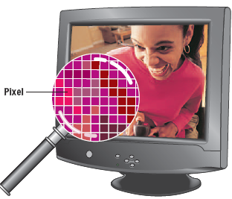 

**Figure 7.9: Monitor resolution Table 7.1: Resolution standards**

* **Dot (pixel) pitch** is the distance between each pixel. Most new monitors have a dot pitch of 0.31 mm or less. The lower the dot pitch (the shorter the **Monitor resolution** distance between pixels), the clearer the images produced.
* **Contrast ratio** indicates a monitor’s ability to display colours. It compares the light intensity of the brightest white to the darkest black. The higher the ratio, the better the monitor. Good monitors typically have contrast ratios between 500:1 and 2000:1.
* Size, or **active display area,** is measured by the diagonal length of a monitor’s viewing area. Common sizes are 15, 17, 19, 21, and 24 inches.
* **Aspect ratio** is determined by the width of a monitor divided by its height. Common aspect ratios for monitors are 4:3 (standard, similar to traditional television pictures) and 16:10 (wide screen).

**7.8.2 Flat-panel monitors**

**Flat-panel monitors** are the most widely used type of monitor today. Compared to other types, they are thinner, are more portable, and require less power to operate.

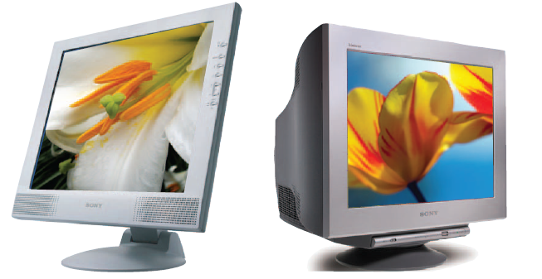

**Figure 7.10: Flat-panel monitor Figure 7.11: CRT monitor**

Many of today’s flat-panel monitors are **LCD (liquid crystal display).** One characteristicof LCD technology is that the monitors are backlit, meaning that a common source of light is dispersed over all pixels on the screen. Although there are many variations of LCD displays, the most common for today’s monitors is the **TFT-LC (thin-film transistor liquid crystal)** in which each pixel is independently activated, producing a high-quality and energy efficient image. **AMOLED (active-matrix organic light-emitting diode)** is a newer technology and is becoming widely used. Unlike LCD, AMOLED technology has the benefits of lower power consumption and longer battery life, as well as possibilities for much thinner displays.

**7.8.3 Cathode-ray tubes**

Just a few years ago, the most common type of monitor for the office and the home was the **cathode-ray tube (CRT, see figure 7.11).** These monitors are typically placed directly on the system unit or on the desktop. CRTs are similar in size and technology to older televisions. Compared to other types of monitors, their primary advantages are low cost and excellent resolution.

Their primary disadvantages are that they are bulky, are less energy efficient, and occupy a considerable amount of space on the desktop.

**7.8.4 Other monitors**

There are several other types of monitors. These monitors are used for more specialized applications, such as reading books, making presentations, and watching television. Three of these specialized devices are book readers, data projectors, and high-definition television.

* **E-book readers** are handheld, book-sized devices that display text and graphics. Using content downloaded from the Web or from special cartridges, these devices are used to read newspapers, magazines, and entire books. These devices use a special type of screen called **electronic paper** or **e-paper** that requires power only when changing pages, and not the entire time a page is displayed on the screen. Two well-known e-book readers are Amazon’s Kindle and Barnes & Noble’s Simple Touch.

Tablets can also display e-books. They are larger, heavier and more expensive than e-book readers. They are also much more flexible, with displaying e-books being only one of their many applications. Unlike dedicated e-book readers, these tablets use LCD displays that provide crisp, colourful images, however, that are difficult to read in bright light due to their reflective nature. Two well-known traditional tablets are Apple’s ipad and Samsung’s Galaxy Tab.

* **Data projectors** are specialized devices similar to slide projectors. These devices, however, connect to microcomputers and project computer output just as it would appear on a monitor. Data projectors are commonly used for presentations almost anywhere from the classroom to the boardroom.
* **Digital or interactive whiteboards** are specializeddevices with a large display connected to a computer or projector. The computer’s desktop is displayed on the digital whiteboard and controlled using specialized pen, a finger, or some other device. Digital whiteboards are widely used in classrooms and corporate boardrooms.
* **High-definition television (HDTV)** delivers a much clearer and more detailed wide-screen picture than regular television. Because the output is digital, users can readily freeze video sequences to create high-quality still images. The video and still images can then be digitized, edited, and stored on disk for later use. This technology is very useful to graphic artists, designers, and publishers. One the most recent and dramatic advances is 3D HDTV. Using special viewing glasses, 3D HDTV provides theater-quality three-dimensional viewing.

**7.9 Printers**

**Printers** translate information that has been processed by the system unit and present the information on paper. Printer output is often called hard copy.

**7.9.1 Features**

There are many different types of printers. Almost all, however, have some basic distinguishing features, including resolution, colour capability, speed, memory, and duplex printing.

* **Resolution** for a printer is similar to monitor resolution. It is a measure of the clarity of images produced. Printer resolution, however, is measured in **dpi (dots per inch).** Most printers designed for personal use average 1,200 dpi. The higher the dpi, the better the quality of images produced.
* **Colour** capability is provided by most printers today. Users typically have the option to print either with just black ink or with color. Because it is more expensive to print in color, most users select black ink for letters, drafts, and homework. Color is used more selectively for final reports containing graphics and for photographs.
* **Speed** is measured in the number of pages printed per minute. Typically, printers for personal use average 15 to 19 pages per minute for single-colour (black) output and 13 to 15 pages per minute for colour output.
* **Memory** within a printer is used to store printing instructions and documents waiting to be printed. The more memory in a printer, the faster it will be able to create large documents.
* **Duplex printing** allows automatic printing on both sides of a sheet of paper. Although not currently a standard feature for all printers, it will likely become standard in the future as a way to reduce paper waste and to protect the environment.

**7.9.2 Ink-jet printers**

**Ink-jet printers** spray ink at high speed onto the surface of paper. This process not only produces a letter-quality image but also permits printing to be done in a variety of colors, making them ideal for select special applications. Ink-jet printers are the most widely used printers. They are reliable, quiet, and relatively inexpensive. The most costly aspect of ink-jet printers is replacing the ink cartridges. For this reason, most users specify black ink for the majority of print jobs and use the more expensive color printing for select applications. Typical ink-jet printers produce 17 to 19 pages per minute of black-only output and 13 to 15 pages of color output.

**7.9.3 Laser printers**

The **laser printer** uses a technology similar to that used in a photocopying machine. Laser printers use a laser light beam to produce images with excellent letter and graphics quality. More expensive than ink-jet printers, laser printers are faster and are used in applications requiring high quality output. There are two categories of laser printers. **Personal laser** **printers** are less expensive and are used by many single users. They typically can print 15 to 17 pages a minute. **Shared laser printers** typically support color, are more expensive, and are used (shared) by a group of users. Shared laser printers typically print over 50 pages a minute.

**7.9.4 Other printers**

There are several other types of printers. These printers include cloud printers, thermal printers, plotters and photo printers:

* **Cloud printers** are printers connected to the internet that provide printing services to others on the internet. Google Cloud Print is a service that supports cloud printing. Once the user activates a printer using Google Chrome Os, the user can access that printer anywhere with an internet connection.
* **Thermal printers** use heat elements to produce images on heat-sensitive paper. These printers are widely used with ATMs and gasoline pumps to print receipts.
* **Plotters** are special-purpose printers for producing a wide range of specialized output. Using output from graphics tablets and other graphical input devices, plotters create maps, images, and architectural and engineering drawings. Plotters are typically used by graphic artists, engineers, and architects to print out designs, sketches, and drawings.
* **Photo printers** are special-purpose printers designed to print photo quality images from digital cameras. Most photo printers print 3 × 5 " or 4 × 6 " images on glossy, photo-quality paper.

**7.10 Audio-output devices**

Audio-output devices translate audio information from the computer into sounds that people can understand. The most widely used audio-output devices are **speakers** and **headsets.** These devices are connected to a sound card in the system unit. The sound card is used to capture as well as play back recorded sounds. Audio-output devices are used to play music, vocalize translations from one language to another, and communicate information from the computer system to users.

Creating voice output is not anywhere near as difficult as recognizing and interpreting voice input. In fact, voice output is quite common. It is used with many soft-drink machines, telephones, and cars. It is used as a reinforcement tool for learning, such as to help students study a foreign language. It also is used in many supermarkets at the checkout counter to confirm purchases.

One of its most powerful capabilities is to assist the physically challenged.

**Portable Media Players**

Portable Media Players, also known as digital media players, are electronic devices for storing and playing digital media. Some of the best known specialized audio and video players are Apple ipod, Creative Zen, and Microsoft Zune.

One of the most recent applications for portable media players is to watch live TV. This is possible through mobile digital television (mobile DTV) technology, which allows television stations to broadcast their programming directly to smartphones, computers and digital media players.

**7.11 Combination input and output devices**

Many devices combine input and output capabilities. Sometimes this is done to save space. Other times it is done for very specialized applications. Common combination devices include fax machines, multifunctional devices, Internet telephones and robots.

**7.11.1 Fax machines**

A **fax machine** is a standard tool in nearly every office. At one time, all fax machines were separate stand-alone devices for sending and receiving images over telephone lines. Now, most computer systems have that capability with the simple addition of a fax/modem board. To send a fax, these devices scan the image of a document converting the light and dark areas into a format that can be sent electronically over standard telephone lines. To receive a fax, these devices reverse the process and print the document (or display the document on your monitor) using signals received from the telephone line.

**7.11.2 Multifunctional devices**

**Multifunctional devices (MFD)** typically combine the capabilities of a scanner, printer, fax, and copy machine. These multifunctional devices offer a cost and space advantage. They cost about the same as a good printer or copy machine but require much less space than the single-function devices they replace. Their disadvantage is that the quality and functionality are not quite as good as those of the separate single-purpose devices. Even so, multifunctional devices are widely used in home and small business offices.

**7.11.3 Internet telephones**

**Internet telephones** are specialized input and output devices for receiving and sending voice communication. **Voice over IP (VoIP)** is the transmission of telephone calls over computer networks. Also known as **telephony, Internet telephony,** and **IP telephony** VoIP uses the Internet rather than traditional communication lines to support voice communication. To place telephone calls using Internet telephony requires a high-speed Internet connection and special software and/or hardware. Skype and Vonage are two examples of popular Internet telephony service providers. The three most popular approaches are:

* **Computer-to-computer** communications allow individuals to place free long-distance calls. This application requires that both parties have a computer and that their computers are on and connected to the Internet when a call is placed. The required software is available from a variety of sources for free or at very low cost.
* **Computer-to-traditional telephone** communications allow a user to call almost any traditional telephone from his or her computer. Only the person making the call needs to have a computer connected to the Internet. The calling party subscribes to a special Internet phone service provider that supplies the required software and charges a small monthly and/or per-minute fee.
* **Traditional telephone-to-traditional telephone** communications do not require a computer. The calling party subscribes to a special Internet phone service provider that supplies a special hardware adapter that connects a traditional telephone to the Internet. The cost for this service is similar to the computer-to-traditional telephone approach.

Compared to traditional telephone calls, Internet-supported calls may have a lower sound quality and may have an audio delay. However, most users report that this difference is not significant.

**7.11.4 Robots**

Artificial intelligence (AI) is a field of computer science that attempts to develop computer systems that can mimic or simulate human senses, thought processes and actions. Robotics is an area of AI concerned with developing and using robots. Robots are computer controlled machines that mimic the motor activities of living things. For example, Honda’s ASIMO robot resembles a human and is capable of walking upstairs, dancing, shaking hands, playing musical instruments and much more. Robots are used for a variety of applications ranging from domestic to manufacturing to military operations. There are four types of robots.

* **Perception system robots** imitate some of the human senses. For example, robots with television –camera vision systems are particularly useful. They can guide machine tools, inspect products and secure homes.
* **Industrial robots** are used to perform a variety of tasks. For example, in automotive plants, robots are widely used for welding, polishing and painting.
* **Mobile robots** act as transports and are widely used for a variety of different tasks. For example, the police and military use them to locate and disarm explosive devices.
* **Household robots** are now widely available and are designed to vacuum or scrub floors, mow lawns, patrol the house or simply provide entertainment.